using System;

namespace ConsoleApp38

{

class Program

{

static void Main(string[] args)

{

int sumofodd = 0;

for (int i = 0; i < 50; i++)

{

if (i % 2==0)

{

Console.WriteLine("{0} is Even", i);

}

else

{

Console.WriteLine("{0} is Odd", i);

sumofodd += i;

}

}

Console.WriteLine("{0} is a sum of Odd no", sumofodd);

}

}

}

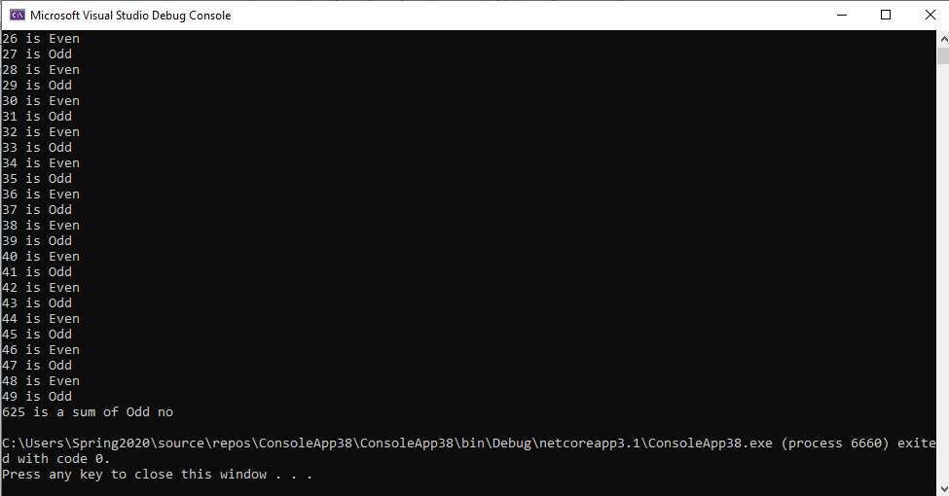

using System;

namespace ConsoleApp38

{

class Program

{

static void Main(string[] args)

{

for (int i = 97; i < 123; i++)

{

Console.Write("{0},", (Char)i);

}

}

}

}

